Title

# Automatic Vehicle Detection for Self Driving Cars

The objective of this chapter is to teach self driving cars how to detect other cars in traffic and track their movement. This approach is using just a camera as input , which is much cheaper than RADAR and LIDAR. [1] Good results can be obtained by using deep learning models or computer vision and Support Vector Machine (SVM) classifiers.

A solution using SVM and CV will be presented, applying the following procedures to the images obtained by the camera.

## HOG feature extraction

HOG (Histogram of gradient descents) is a powerful computer vision technique to identify the shape of an object using the direction of gradient along its edges. We can implement it using skimage.hog() function. The key parameters are ‘orientations’, ‘pixels_per_cell’ and ‘cells_per_block’. Orientations is the number of gradient directions. The pixels_per_cell parameter specifies the cell size over which each gradient histogram is computed. The cells_per_block parameter specifies the local area over which the histogram counts in a given cell will be normalized. To get a feel for the affect of pixels_per_cell and cells_per_block, I looked at hog images with different settings for pixels per cell and cells per block.

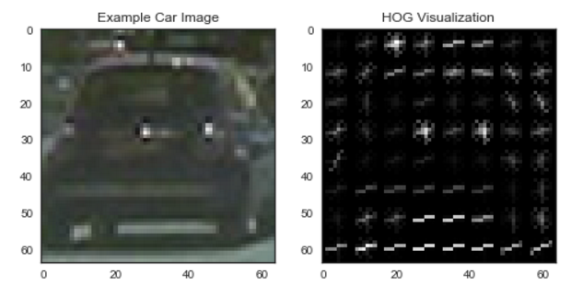

Figure 1:HOG — 8 pixels per cell and 1 cell per block

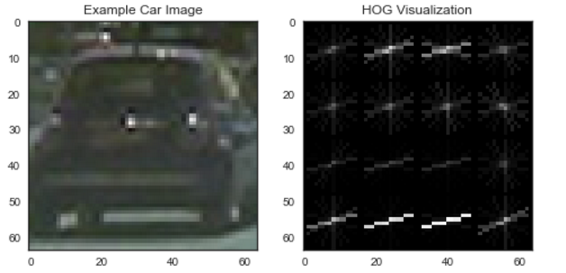

Figure 2: HOG — 16 pixels per cell and 1 cell per block

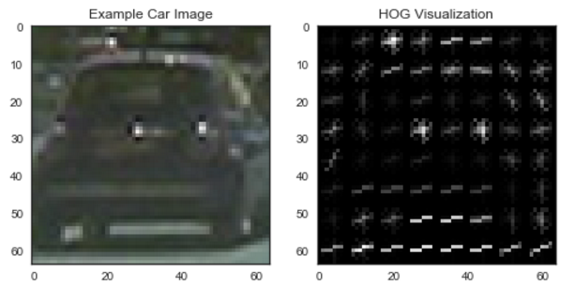

Figure 3:HOG — 8 pixels per cell and 2 cell per block

Low no. of pixels per call and high cells per block (last image above) has the most HOG features making it fairly easy to detect a car. However it would also mean slow computation.